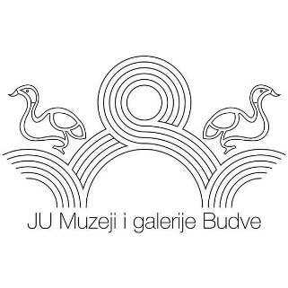
Public Institution Museums and Galleries of Budva
Memorial home “Crvena komuna”

FOURTH BIENNIAL OF FINE ART NUDE “MARKO GREGOVIĆ“, PETROVAC, SEPTEMBER 2018

Name and surname of the artist __________________________________________

Adress and city_______________________________________________________

Postal code ________________________

E-mail address ____________________________

Telephone number __________________

Work 1

Tittle __________________________________________________________

Technique______________________________________________________

Dimensions ____________________________________________________

Year __________________________________________________________

Work 2

Tittle __________________________________________________________

Technique _____________________________________________________

Dimensions ____________________________________________________

Year __________________________________________________________

Work 3

Tittle__________________________________________________________

Technique _____________________________________________________

Dimensions ____________________________________________________

Year __________________________________________________________

