ABOUT THE ARTIST
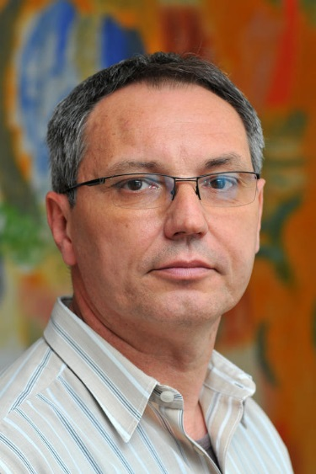
Branko Lepen was born in Čakovec on May 25, 1957. He took his degree at the Civil Engineering Faculty in Zagreb in 1983. Up to 1989 he was engaged in the construction industry. In 1989 he started to work in the Croatian National Theatre in Zagreb as stage manager and from 2006 as technical manager in the same theatre. Since 2016 he has been head of the technical division of the Kerempuh Theatre. He has been exhibiting solo since 1982, and since 2010 he has done the stage sets for several big operas and ballets. His sculptures are kept in the collections of the Museum of Contemporary Art in Zagreb, in the Modern Gallery in Zagreb and the MMCA Rijeka, the Croatian Academy of Sciences and Arts Glyptotheque, Zagreb.

