OPEN CALL FOR ARTISTS-IN-RESIDENCE 2027
Rolling applications for Jan 2027 | Dec 31, 2026 for Oct 2027 term

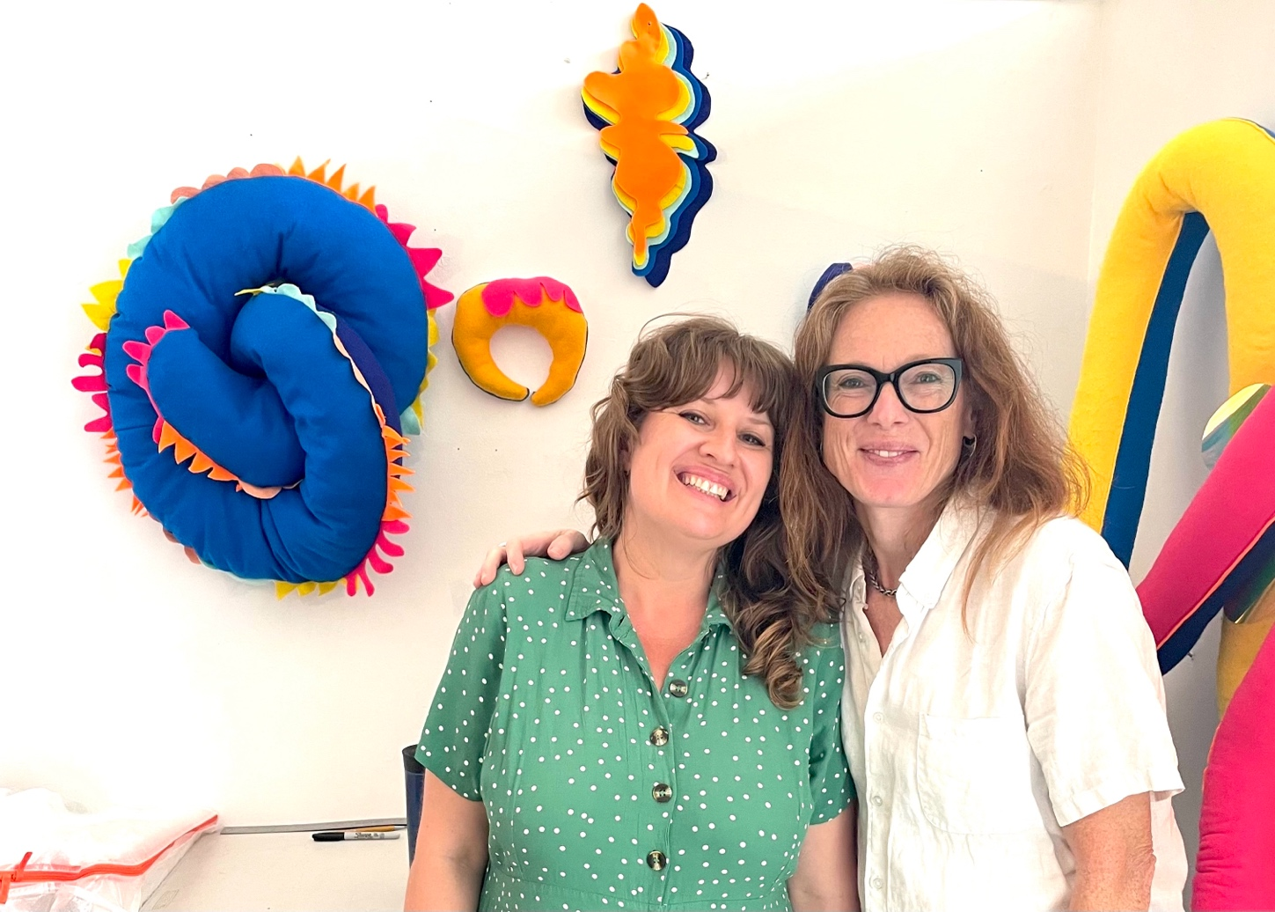
2025 AIR Faye Harnest and NYC gallerist Sally Morgan, of Morgan Lehman Gallery, during a studio visit

KUNSTRAUM is accepting submissions for our 2027 AIR Program.
Rolling deadline for Jan 2027 // Dec 31, 2026, deadline for later 2027 terms.
KUNSTRAUM is a pioneering, artist-led gallery and residency program in New York City dedicated to artistic production, collaboration, and exchange. Since its founding, KUNSTRAUM has cultivated a vibrant international community where artists and curators come together to experiment, challenge conventions, and develop new perspectives in contemporary art. With a strong commitment to emerging voices and cross-disciplinary practices, KUNSTRAUM fosters an environment where critical dialogue and creative risk-taking are at the forefront.
Our Artist-in-Residence (AIR) program offers three-month residencies for national and international artists, organized on a quarterly cycle. We currently have a few spots open for the 2027 cycles: January-March, and October-December. Applications for the January term will be reviewed on a rolling basis, please submit your application now.
The residency program supports artists in developing independent projects while embedding them within KUNSTRAUM's active creative network. Residents engage with a diverse community of artists, designers, filmmakers, and curators. They are invited to participate in monthly salons, field trips, and studio visits, connect with participants in our ongoing exhibition program, and contribute to the annual Members Show in the fall.
Situated within our Brooklyn space, the program offers a dynamic context that bridges studio practice, curatorial exchange, and public presentation — encouraging artists to expand their work within a collaborative and internationally connected framework.
To learn more about KUNSTRAUM, please visit our website and Instagram.
Each residency includes:
- A desk-sized studio in our partitioned lofts with 24/7 access (no living). The semi-private studios inside the large open lofts range from 49 to 89 square feet.
- Participation in our annual Members Show, including studio visit, professional documentation, and programming. Sales opportunities during the show plus via an online gallery for the duration of 6 months.
- Access to our gallery space for 3 days for free to put on your own show or install and photograph work.
- An artist community with 19 members and more than 200 alumni to meet and share with.
- Monthly studio visits by 1-2 New York curators, gallerists, critics, art advisors.
- Two studio visits with our Curator and Community Affiliate (CCA).
- Monthly salons with artist community, field trips, social media promotion and a feature of your work on our website.
- Access to our internal monthly newsletter, which includes news, events, and an open call list with exhibition, grant, and residency opportunities.
- Community events for all resident and member artists to attend. These community events can include gallery openings, curator walk-throughs, discussions, salons, and open studios.
The studio spaces have 24/7 access with a freight elevator, 13-foot ceilings, a slop sink, and secure Wi-Fi. They are meant to be used only for work with non-toxic materials. All painters must work on a non-toxic basis. Blick Art Supply, hardware stores, the post office, print shops, supermarkets, restaurants, and delis are just 1.5 blocks away, and Home Depot is a short 10-block walk. No living is included. The resident artist is responsible for finding their own living and visa arrangements.
Fees: The residency fee is $800 per month in 2027, with the following start dates: 1/1/2027; 10/1/2027.
To Apply:
Please submit all materials via email to Louis Block at md@kunstraumllc.com including:
- Statement of Motivation with starting date/s and 3-month project - 200 words
- Statement on private or public funding plan - 100 words or less
- Portfolio with max. 10 pages with 10-20 images - no larger than 5 MB
- CV with max. 5 pages
- Links to website, Instagram, recent exhibition or press
- Optional: 2 links to 1-2 mins video excerpts (specify cue in and out)
Incomplete applications will not be considered.
KUNSTRAUM is born out of a necessity to create community and foster collaboration between artists, architects, curators, designers, filmmakers, and writers. The KUNSTRAUM model features excellent studio locations, networking, research opportunities, and discourse for creative production. Founded in New York City in February 2015, we now seek to expand to Berlin. KUNSTRAUM’s global identity is designed to offer and promote an international community, mobility, and visibility in the visual arts. Recent press coverage includes Communication Arts, Creator’s Project, Huffington Post, Artnet News, Interview Magazine, Art F City, and Musée Magazine. With "Video Shop," a project at NADA New York, KUNSTRAUM won the 2016 Artfair Goers Award and best booth. To learn more about KUNSTRAUM, please visit the About section of our website as well as our Instagram.
For more information on KUNSTRAUM’s Artist-in-Residence Program, please visit our FAQ page and Testimonials. For all other questions, please reach out to the Managing Director at md@kunstraumllc.com.

